NIKA INSTRUMENT FIRST AID

MACs TO BE MONITORED:

- "Mac mini de Nika" (in "Archeops9", on the main table, remote screen): acquisition.
- "PC NIKA" 192.168.1.31 (in the "Archeops 8", on the main table, remote screen): cryostat.
- Mac "terahertz", not on the main table: acquisition, histogram of the KID (well tuned or not), "historique" window (Sky Temperature along the line of sight)

REMEMBER: A Array (kidA) refers to 1mm, B array (kidB) refers always to 2mm.

"MAC MINI" (on the "Archeops9" screen, main NIKA table, remote screen):

This is the main acquisition Mac for NIKA. It's physically located in the computers room. So we use the Archeops9 big screen to show it.

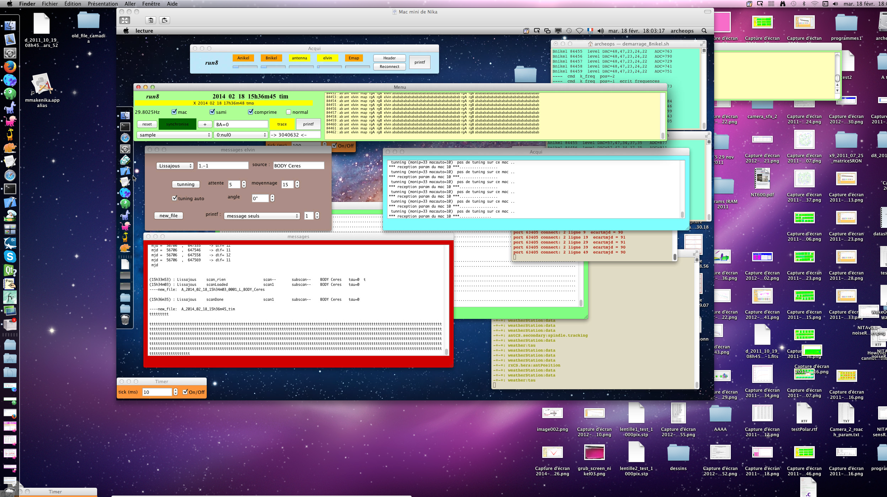
1) CHECK, in the "Acqui" window (at the top), that the five (Anikel, Bnikel, antenna, eleven, Emap) are BLINKING. In case they are not, press "Reconnect". If it doesn't work, wake up Alessandro or Martino.
2) CHECK, in the red "messages" window, that your scans are correctly shown. You should see the name of your source, the type of scan etc. This window takes messages from the telescope and transfer them to the acquisition. For the tuning for example. If no messages are shown, wake up Alessandro or Martino.
3) CHECK, in the browk "messages elvin" window, that the "tuning auto" is selected. Should always be the case during observations.

MAC "TERAHERTZ" (not on the NIKA main table):

This is the main Mac in charge of saving raw data files. Locally on the MAC copying them on "Sami" (a Linux computer physically located in the computers room and used for example to run the Real Time Analysis).
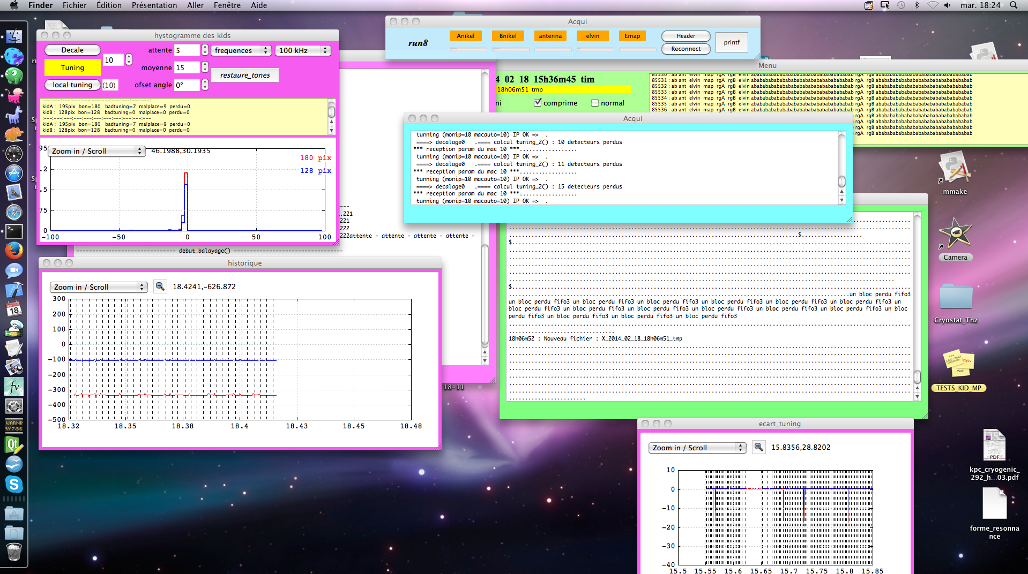
1) CHECK, in the "Acqui" window (at the top), that the five (Anikel, Bnikel, antenna, eleven, Emap) are BLINKING. In case they are not, press "Reconnect". If it doesn't work, wake up Alessandro or Martino.
2) BEFORE LAUNCHING A SCAN, check that in the "hystogramme of the kids" pink window the distribution is well peaked. And the number of 'Akid' and 'Bkid' that are said 'bon' (OK) are above respectively 160 and 120. In this window, each vertical broken line represent a 'tuning'. Wait a few tunings before panic. Sometimes a single tuning isn't enough to recover the resonances. IN REALLY BAD SKY (REALLY CRAPPY) IT IS POSSIBLE THAT THE TUNING DOESN'T WORK. In this case, if you decide it's pointless to observe wait for better Sky. In case you want to try to continue, wake up Alessandro or Martino.
3) CHECK (if you want), in the "historique" pink window, the absolute position of the resonances (RED=1mm, BLEU=2mm). The Azure line at 0kHz is the reference taken with the detectors on 80K equivalent background. If you want to get a rough idea about the Sky temperature (along the line of NIKA sight) take f_red and calculate: T_sky (K) = 80 - f_red * (120/300). Negative frequencies mean bad Sky, positive good Sky. Curves going 'up' means improving Sky, going 'down' means worse. More reliable than the observatory taumeter IF THE RESONANCES ARE WELL TUNED (see histogram).

"PC NIKA" (on the "Archeops8" screen, main NIKA table, remote screen):

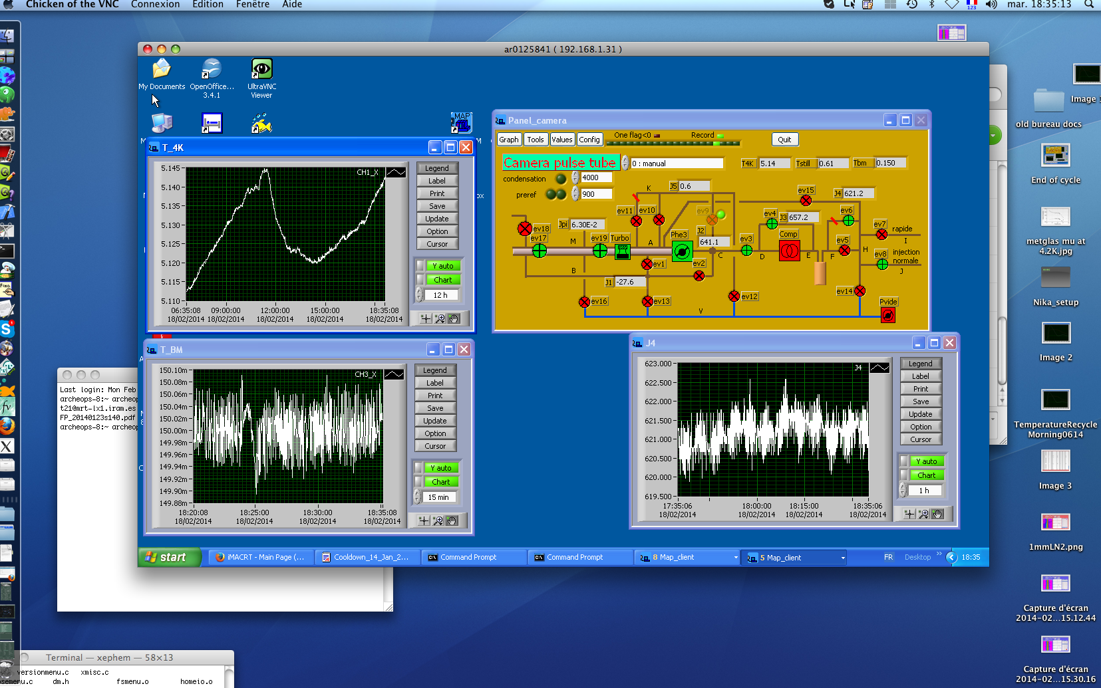
1) CHECK T_BM (detectors temperature = 150mK and stable at 1mK)
2) CHECK T_4K (cryo machine temperature, not to go above 5.5K)
3) CHECK J4 (injection pressure, mbar. Not to increase by more than 50 mbar per hour)

